WODA Child Assessment Report, May 2017

In December 2016, the Women of Dignity Alliance (WODA), in collaboration with an expert consultant, conducted a scoping report to better understand the situation of sexually exploited girls in Old Fadama, Accra. For more information please read the scoping report:
http://www.tfacafrica.com/wp-content/uploads/2014/07/Scoping-Report-Sexually-Exploited-Girls-in-Old-Fadama-M-John-Baptiste.pdf

In response to the recommendations made in the report, WODA facilitators interviewed 42 girls who they encountered in Old Fadama, Railways and Jamestown in February and March 2017, who they suspected to be victims of sexual exploitation.

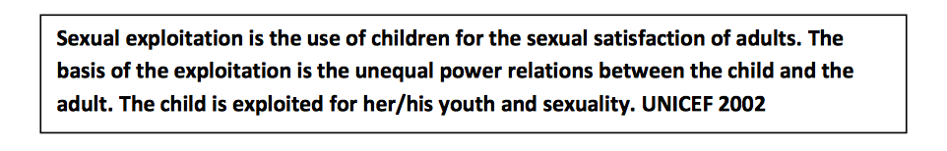

The facilitators asked the girls a series of questions in order to assess their situation and their needs. The results of this investigation are outlined below:

1. Initial Contact

- 22 girls were observed and approached by facilitators
- 10 girls were referred to WODA by a community member
- 10 girls were referred by a member of the WODA Network of female sex workers

2. Young person’s information

Gender:

- All children were female
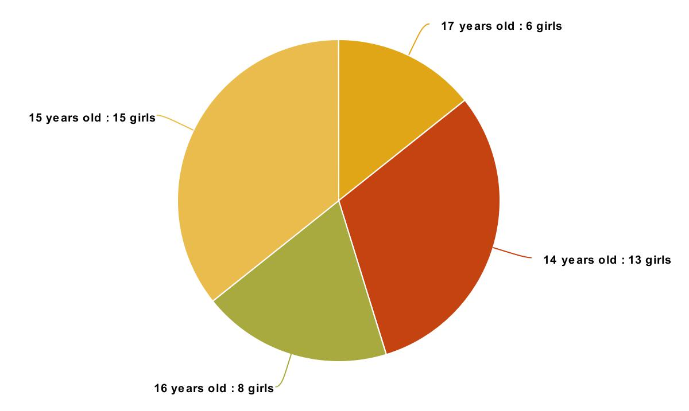
Age:

Description / Family details / situation:

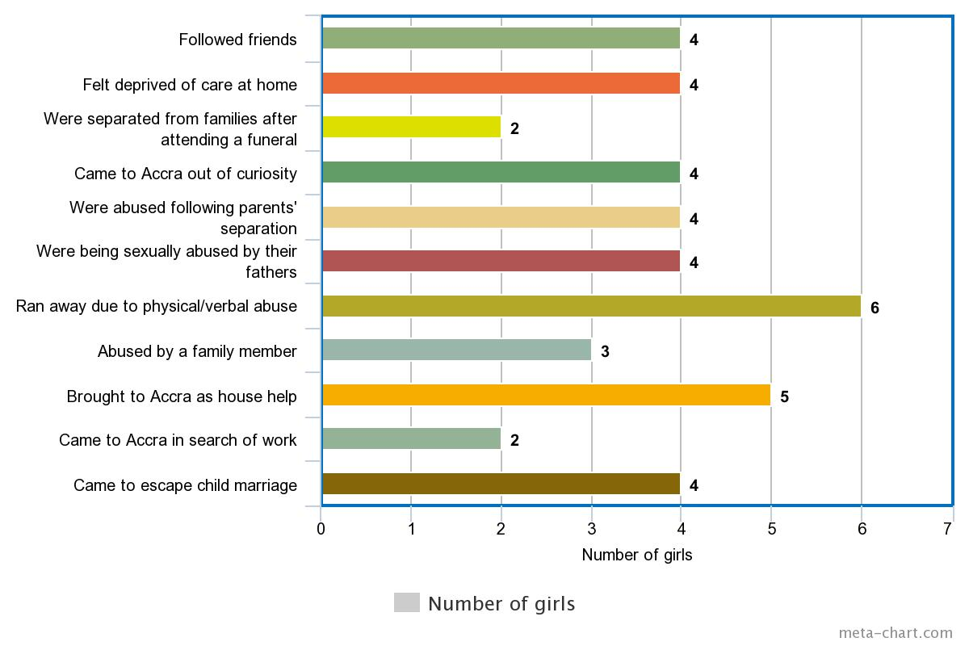

History of pregnancy:

During interviews with the girls about their sexual and reproductive health, it was reported that:

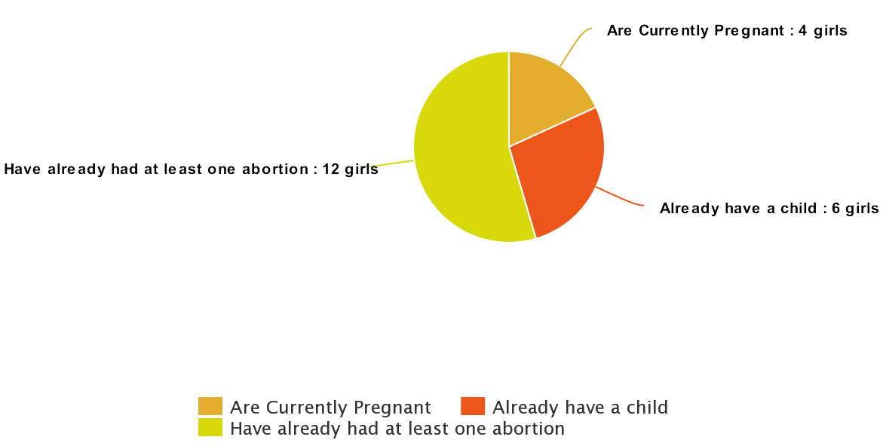

3. WODA concerns re: sexual exploitation and trafficking

- WODA facilitators assessed all 42 girls as being sexually exploited
- WODA facilitators assessed that 26 of the 42 girls had been trafficked

4. Other Concerns
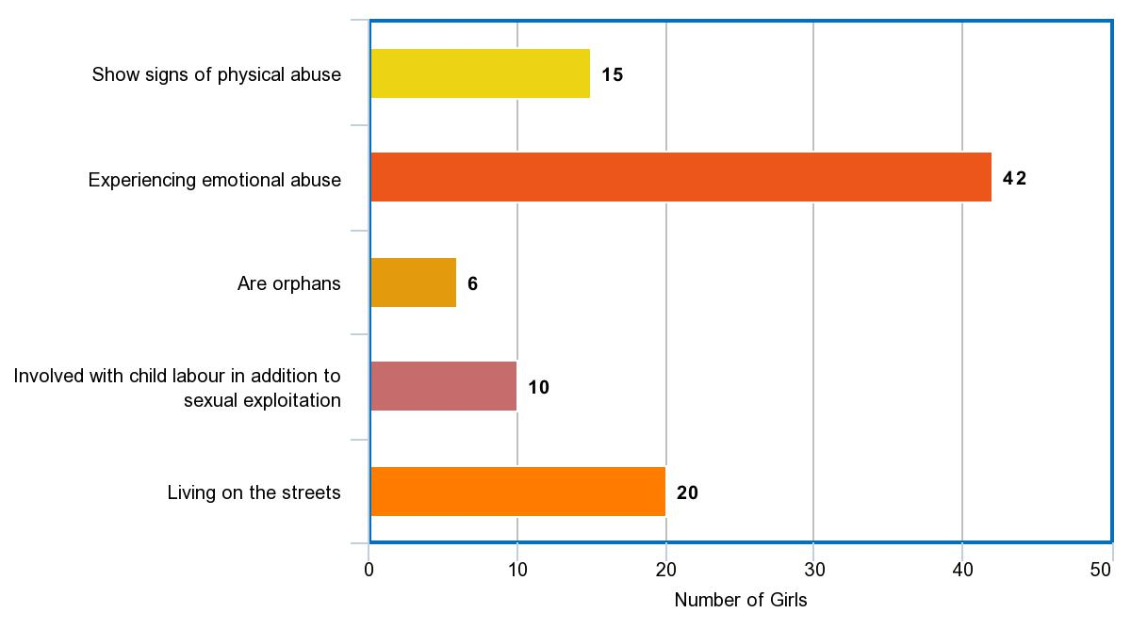

5. Reporting

- 5 girls have been arrested by the police
- 0 girls have been in contact with DOVVSU
- 0 girls have been in contact with Social Welfare

When asked who they would turn to if they needed help:
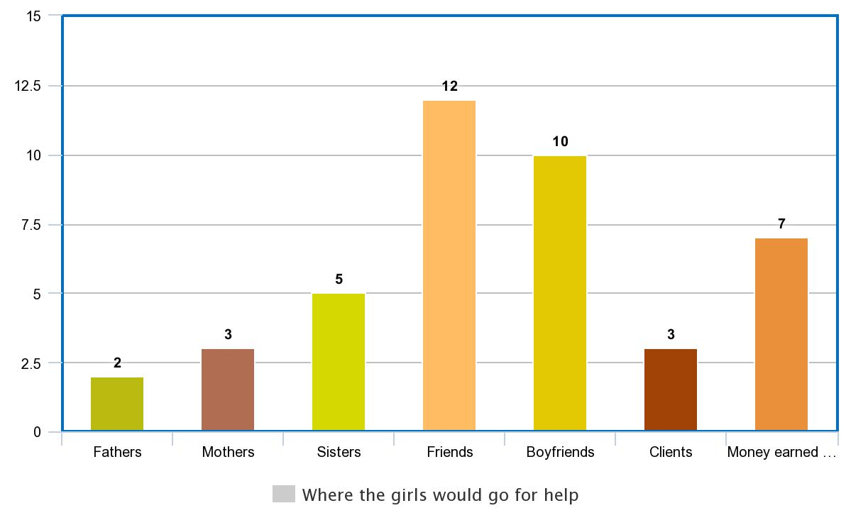

6. Future

When asked what they wanted to do:
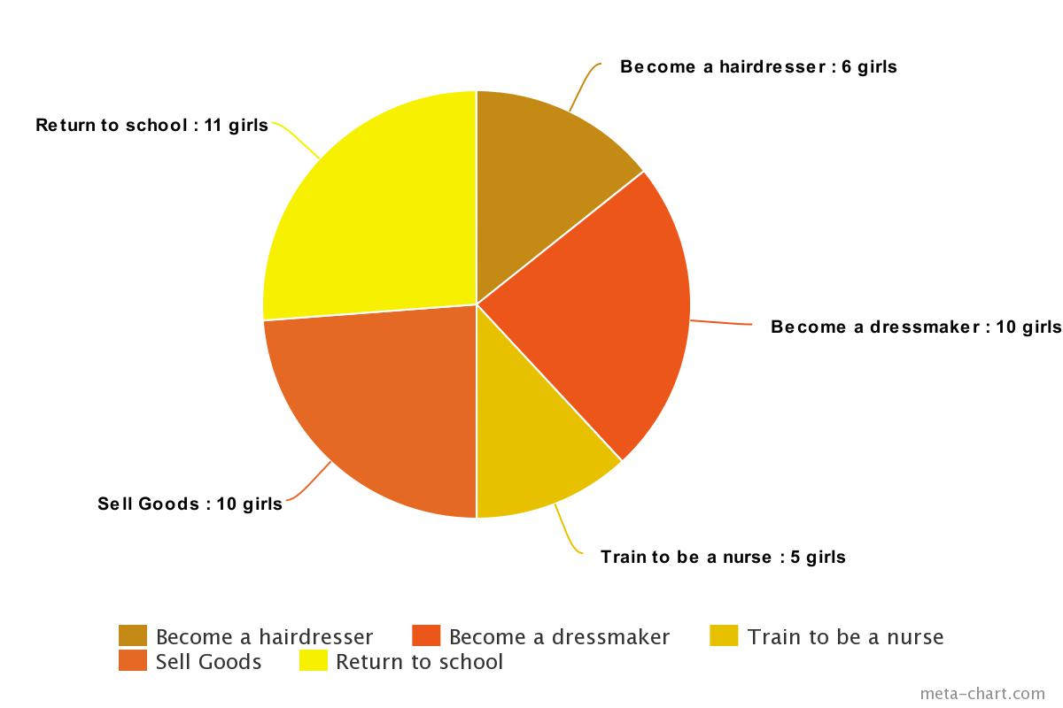

When asked what WODA or another organisation could do to help:

The girls mentioned:
- Supporting them to go back to school
- Providing jobs
- Advising girls how to live healthy lives
- Advocating against sexual exploitation
- Reaching out to girls from their villages to stop them coming to Accra

For further information please contact:

Susana Dartey, Project Manager, Women of Dignity Alliance Ghana, susana.dartey@wodaghana.com
Fiona Morrell, Head of Grants, Theatre for a Change UK, fiona.morrell@tfacafrica.com

